

**PRACTICAL JOURNAL OF PRINCIPLES OF PROGRAMMING LANGUAGES**

**(CS-6002)**

**BE: Third-Year**

Department of Computer Science & Engineering

|  |  |  |
| --- | --- | --- |
| **Name of Student** | **:** | **Shachita Jain** |
| **Branch & Section** | **:** | **CS D** |
| **Roll Number** | **:** | **0827CS161203** |
| **Year** | **:** | **III** |

**Department of Computer Science &Engineering**

**AITR, INDORE**

**ACROPOLIS INSTITUTE OF TECHNOLOGY & RESEARCH, INDORE**

**Department of Computer Science & Engineering**

**Certificate**

This is to certify that the experimental work entered in this journal as per the BE **Third** year syllabus prescribed by the RGPV was done by Mr. **Shachita Jain (0827CS161203)** BE **III-year VI** semester in the **Principles of Programming Languages** Laboratory of this institute during the academic year **2018-2019**.

**Signature of Head Signature of Faculty**

**Week-1** **OPERATORS AND EVALUATION OF EXPRESSIONS (DATE: 31/01/19)**

1. Write a C program to check whether a number is even or odd using ternary operator.
2. Write a C program to perform the addition of two numbers without using + operator.
3. Write a C program to evaluate the arithmetic expression ((a + b / c * d - e) * (f - g)). Read the values a, b, c, d, e, f, g from the standard input device.
4. Write a C program to find the sum of individual digits of a 3 digit number.
5. Write a C program to read the values of x and y and print the results of the following expressions in one line:
6. (x + y) / (x - y)
7. (x + y)(x - y)

**Grade for Week-1: ______________________**

**Signature: ________________**

**Week-2** **CONTROL STRUCTURES (DATE: 14/02/19)**

1. Write a C program to find the sum of individual digits of a positive integer.
2. A Fibonacci sequence is defined as follows: the first and second terms in the sequence are 0 and 1. Subsequent terms are found by adding the preceding two terms in the sequence. Write a C program to generate the first n terms of the sequence.
3. Write a C program to generate all the prime numbers between 1 and n, where n is a value supplied by the user.
4. A character is entered through keyboard. Write a C program to determine whether the character entered is a capital letter, a small case letter, a digit or a special symbol using if-else and switch case. The following table shows the range of ASCII values for various characters.

|  |  |
| --- | --- |
| **Characters** | **ASCII values** |
| A – Z | 65 – 90 |
| a – z | 97 – 122 |
| 0 – 9 | 48 – 57 |
| Special symbols | 0 – 47, 58 – 64, 91 – 96, 123 – 127 |

1. If cost price and selling price of an item is input through the keyboard, write a program to determine whether the seller has made profit or incurred loss. Write a C program to determine how much profit or loss incurred in percentage.

**Grade for Week-2: ______________________**

**Signature: ________________**

**Week-3** **CONTROL STRUCTURES (DATE: 28/02/19)**

1. Write a C program, which takes two integer operands and one operator from the user, performs the operation and then prints the result. (Consider the operators +, -, *, /, % and use switch statement).
2. Write a Write a C program to calculate : 1 - x2/2! + x4/4! – x6/6! + x8/8! – x10/10!
3. Write a C program to find the roots of a quadratic equation.
4. Write a C program to check whether a given 3 digit number is Armstrong number or not.
5. Write a C program to print the numbers in triangular form

1

1 2

1 2 3

1 2 3 4

**Signature: ________________**

**Grade for Week-3: ______________________**

**Week-4** **ARRAYS (DATE: 14/03/19)**

1. Write a C program to find the second largest integer in a list of integers.
2. Write a C program to perform the following:
3. Addition of two matrices
4. Multiplication of two matrices
5. Write a C program to count and display positive, negative, odd and even numbers in an array.
6. Write a C program to merge two sorted arrays into another array in a sorted order.
7. Write a C program to find the frequency of a particular number in a list of integers.

**Grade for Week-4: ______________________**

**Signature: ________________**

**Week-5** **STRINGS (DATE: 28/03/19)**

1. Write a C program that uses functions to perform the following operations:
2. To insert a sub string into a given main string from a given position.
3. To delete n characters from a given position in a given string.
4. Write a C program to determine if the given string is a palindrome or not.
5. Write a C program to find a string within a sentence and replace it with another string.
6. Write a C program that reads a line of text and counts all occurrence of a particular word.
7. Write a C program that displays the position or index in the string S where the string T begins, or 1 if S doesn't contain T.

**Grade for Week-5: ______________________**

**Signature: ________________**

|  |  |  |  |
| --- | --- | --- | --- |
| **Name of Student: Shachita Jain** | | | **Class: CS-D** |
| **Enrollment No: 0827CS161203** | **Week Number: 01** | | **Batch: B1** |
| **Date of Experiment:** | **Date of Submission:** | | **Submitted on:** |
| **Remarks by faculty:** | | | **Grade:** |
| **Signature of student:** | | **Signature of Faculty:** | |

**Name of Program-1:** Write a C program to check whether a number is even or odd using ternary operator.

**Source Code:**

#include <iostream>

using namespace std;

int main(){

    int a;

    cout << "Enter a number: ";

    cin >> a;

     (a%2==0)? cout << "Number is Even!": cout << "Number is Odd!";

    return 0;

}

**Output Screen:**

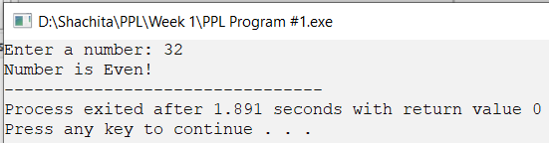

|  |  |  |  |
| --- | --- | --- | --- |
| **Name of Student: Shachita Jain** | | | **Class: CS-D** |
| **Enrollment No: 0827CS161203** | **Week Number: 01** | | **Batch: B1** |
| **Date of Experiment:** | **Date of Submission:** | | **Submitted on:** |
| **Remarks by faculty:** | | | **Grade:** |
| **Signature of student:** | | **Signature of Faculty:** | |

**Name of Program-2:** Write a C program to perform the addition of two numbers without using + operator.

**Source Code:**

#include <iostream>

using namespace std;

int main(){

    int a,b;

    cout << "Enter number 1: ";

    cin >> a;

    cout << "Enter number 2: ";

    cin >> b;

    cout << "Addition is: " << a-(~b) - 1;

    return 0;

}

**Output Screen:**

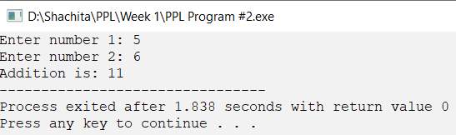

|  |  |  |  |
| --- | --- | --- | --- |
| **Name of Student: Shachita Jain** | | | **Class: CS-D** |
| **Enrollment No: 0827CS161203** | **Week Number: 01** | | **Batch: B1** |
| **Date of Experiment:** | **Date of Submission:** | | **Submitted on:** |
| **Remarks by faculty:** | | | **Grade:** |
| **Signature of student:** | | **Signature of Faculty:** | |

**Name of Program-3:** Write a C program to evaluate the arithmetic expression ((a + b / c * d - e) * (f - g)). Read the values a, b, c, d, e, f, g from the standard input device.

**Source Code:**

#include <iostream>

using namespace std;

int main(){

    int a,b,c,d,e,f,g;

    cout << "Expression is: ((a+b/c*d-e)*(f-g))!\n" ;

    cout << "Input the values: ";

    cin >> a>> b>> c>> d>> e>> f>> g;

    cout << "Answer is: " << ((a+b/c*d-e)*(f-g));

    return 0;

}

**Output Screen:**

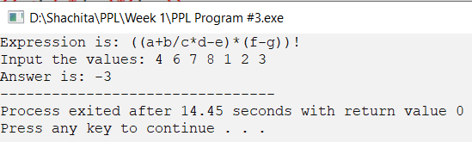

|  |  |  |  |
| --- | --- | --- | --- |
| **Name of Student: Shachita Jain** | | | **Class: CS-D** |
| **Enrollment No: 0827CS161203** | **Week Number: 01** | | **Batch: B1** |
| **Date of Experiment:** | **Date of Submission:** | | **Submitted on:** |
| **Remarks by faculty:** | | | **Grade:** |
| **Signature of student:** | | **Signature of Faculty:** | |

**Name of Program-4:** Write a C program to find the sum of individual digits of a 3 digit number.

**Source Code:**

#include <iostream>

using namespace std;

int main(){

    int a,sum=0, rem=0;

    do{

    cout << "Enter a 3 digit number: ";

    cin >> a;

    }while(a< 100 || a > 999);

    while(a){

        rem = a%10;

        sum += rem;

        a /=10;

    }

    cout << "Sum of digits is: "<< sum;

    return 0;

}

**Output Screen:**

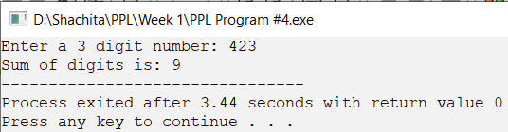

|  |  |  |  |
| --- | --- | --- | --- |
| **Name of Student: Shachita Jain** | | | **Class: CS-D** |
| **Enrollment No: 0827CS161203** | **Week Number: 01** | | **Batch: B1** |
| **Date of Experiment:** | **Date of Submission:** | | **Submitted on:** |
| **Remarks by faculty:** | | | **Grade:** |
| **Signature of student:** | | **Signature of Faculty:** | |

**Name of Program-5:** Write a C program to read the values of x and y and print the results of the following expressions in one line:

1. (x + y) / (x - y)

II. (x + y)(x - y)

**Source Code:**

#include <iostream>

using namespace std;

int main(){

    double x,y;

    cout << "Enter x: ";

    cin >> x;

    cout << "Enter y: ";

    cin >> y;

    cout << "i. (x+y)/(x-y) = " << (x+y)/(x-y)<<"\n";

    cout << "ii. (x+y)(x-y) = " << (x+y)*(x-y);

    return 0;

}

**Output Screen:**

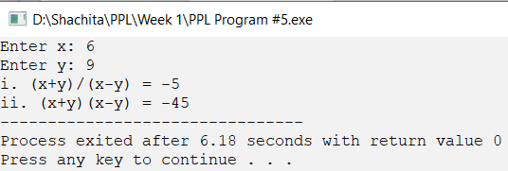

|  |  |  |  |
| --- | --- | --- | --- |
| **Name of Student: Shachita Jain** | | | **Class: CS-D** |
| **Enrollment No: 0827CS161203** | **Week Number: 02** | | **Batch: B1** |
| **Date of Experiment:** | **Date of Submission:** | | **Submitted on:** |
| **Remarks by faculty:** | | | **Grade:** |
| **Signature of student:** | | **Signature of Faculty:** | |

**Name of Program-1:** Write a C program to find the sum of individual digits of a positive integer.

**Source Code:**

#include <iostream>

using namespace std;

int main(){

    int a,rem=1, sum=0;

    do{

        cout << "Enter a number: ";

        cin >> a;

    }while(a<0);

    while(a){

        rem = a % 10;

        a/=10;

        sum+=rem;

    }

    cout << "Sum of digits is: " << sum;

}

**Output Screen:**

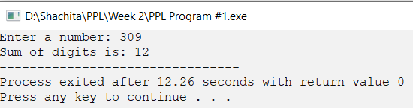

|  |  |  |  |
| --- | --- | --- | --- |
| **Name of Student: Shachita Jain** | | | **Class: CS-D** |
| **Enrollment No: 0827CS161203** | **Week Number: 02** | | **Batch: B1** |
| **Date of Experiment:** | **Date of Submission:** | | **Submitted on:** |
| **Remarks by faculty:** | | | **Grade:** |
| **Signature of student:** | | **Signature of Faculty:** | |

**Name of Program-2:** A Fibonacci sequence is defined as follows: the first and second terms in the sequence are 0 and 1. Subsequent terms are found by adding the preceding two terms in the sequence. Write a C program to generate the first n terms of the sequence.

**Source Code:**

#include <iostream>

using namespace std;

int main(){

    int n,a=0,b=1;

    cout << "Enter the number of fibonacci terms to print: ";

    cin >> n;

    cout << "Fibonacci sequence is: \n";

    for(int i=0; i<n;++i){

        if(i==0) {

            cout << a;

            a=b;

        }

        else if(i==1) cout << b;

        else {

            int c= a;

            a=b;

            b+=c;

            cout << a;

        }

        cout << ".";

    }

    return 0;

}

**Output Screen:**

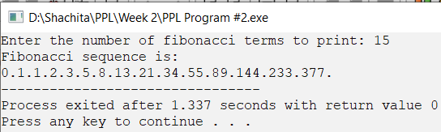

|  |  |  |  |
| --- | --- | --- | --- |
| **Name of Student: Shachita Jain** | | | **Class: CS-D** |
| **Enrollment No: 0827CS161203** | **Week Number: 02** | | **Batch: B1** |
| **Date of Experiment:** | **Date of Submission:** | | **Submitted on:** |
| **Remarks by faculty:** | | | **Grade:** |
| **Signature of student:** | | **Signature of Faculty:** | |

**Name of Program-3:** Write a C program to generate all the prime numbers between 1 and n, where n is a value supplied by the user.

**Source Code:**

#include <iostream>

using namespace std;

int main(){

    int n;

    cout << "Enter the number to print prime numbers upto: ";

    cin >>n;

    for( int i= 1; i<=n; ++i){

        bool prime = true;

        if(i==1) continue;

        for(int j=2; j<=std::sqrt(i); ++j){

            if(i%j == 0 ) {

                prime= false;

                break;

            }}

        if(prime) cout << i << ".";

}

}

**Output Screen:**

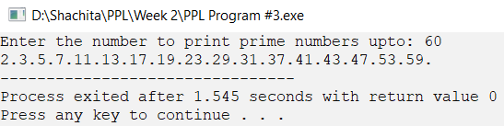

|  |  |  |  |
| --- | --- | --- | --- |
| **Name of Student: Shachita Jain** | | | **Class: CS-D** |
| **Enrollment No: 0827CS161203** | **Week Number: 02** | | **Batch: B1** |
| **Date of Experiment:** | **Date of Submission:** | | **Submitted on:** |
| **Remarks by faculty:** | | | **Grade:** |
| **Signature of student:** | | **Signature of Faculty:** | |

**Name of Program-4:** A character is entered through keyboard. Write a C program to determine whether the character entered is a capital letter, a small case letter, a digit or a special symbol using if-else and switch case. The following table shows the range of ASCII values for various characters.

|  |  |
| --- | --- |
| **Characters** | **ASCII values** |
| A – Z | 65 – 90 |
| a – z | 97 – 122 |
| 0 – 9 | 48 – 57 |
| Special symbols | 0 – 47, 58 – 64, 91 – 96, 123 – 127 |

**Source Code:**

#include <iostream>

using namespace std;

int main(){

    int n;

    cout << "Enter the number to print prime numbers upto: ";

    cin >>n;

    for( int i= 1; i<=n; ++i){

        bool prime = true;

        if(i==1) continue;

        for(int j=2; j<=std::sqrt(i); ++j){

            if(i%j == 0 ) {

                prime= false;

                break;

            }

        }

        if(prime) cout << i << ".";}}

**Output Screen:**

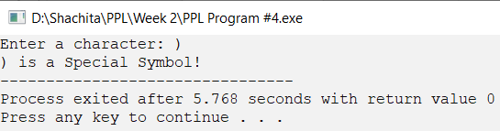

|  |  |  |  |
| --- | --- | --- | --- |
| **Name of Student: Shachita Jain** | | | **Class: CS-D** |
| **Enrollment No: 0827CS161203** | **Week Number: 02** | | **Batch: B1** |
| **Date of Experiment:** | **Date of Submission:** | | **Submitted on:** |
| **Remarks by faculty:** | | | **Grade:** |
| **Signature of student:** | | **Signature of Faculty:** | |

**Name of Program-5:** If cost price and selling price of an item is input through the keyboard, write a program to determine whether the seller has made profit or incurred loss. Write a C program to determine how much profit or loss incurred in percentage.

**Source Code:**

#include <iostream>

using namespace std;

int main(){

    int cp, sp, profit=0, loss=0;

    cout << "Enter Cost Price: ";

    cin >> cp;

    cout << "Enter Selling Price: ";

    cin >> sp;

    if(sp>cp) {

        cout << "Profit Earned: " << sp-cp << " Percentage: " << ((float)(sp-cp)/cp)*100 << "%";

    }

    else cout << "Lost Incurred: " << cp-sp << " Percentage: " << ((float)(cp-sp)/cp)*100 << "%";

}

**Output Screen:**

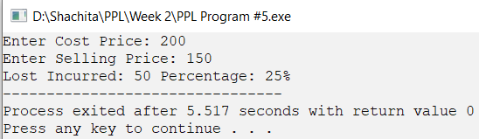

|  |  |  |  |
| --- | --- | --- | --- |
| **Name of Student: Shachita Jain** | | | **Class: CS-D** |
| **Enrollment No: 0827CS161203** | **Week Number: 03** | | **Batch: B1** |
| **Date of Experiment:** | **Date of Submission:** | | **Submitted on:** |
| **Remarks by faculty:** | | | **Grade:** |
| **Signature of student:** | | **Signature of Faculty:** | |

**Name of Program-1:** Write a C program, which takes two integer operands and one operator from the user, performs the operation and then prints the result. (Consider the operators +, -, *, /, % and use switch statement).

**Source Code:**

#include <iostream>

using namespace std;

int main(){

    int a, b; char c;

    cout << "Input two numbers to calculate in the form a+b: ";

    cin >> a>>c>>b;

    cout << "Result is: ";

    switch(c){

        case '+':

            cout << a+b; break;

        case '/':

            cout << a/b; break;

        case '*':

            cout << a*b; break;

        case '-':

            cout << a-b; break;

        case '%':

            cout << a%b; break;

    }

}

**Output Screen:**

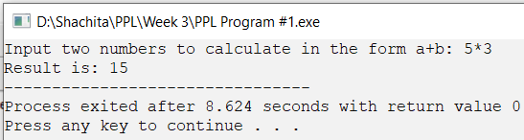

|  |  |  |  |
| --- | --- | --- | --- |
| **Enrollment No: 0827CS161203** | **Week Number: 03** | | **Batch: B1** |
| **Date of Experiment:** | **Date of Submission:** | | **Submitted on:** |
| **Remarks by faculty:** | | | **Grade:** |
| **Signature of student:** | | **Signature of Faculty:** | |

**Name of Program-2:** Write a C program to calculate: 1 - x2/2! + x4/4! – x6/6! + x8/8! – x10/10!

**Source Code:**

#include <iostream>  
using namespace std;  
float power(int x, int num){  
 int k =x;  
 for(int i= 1; i< num; ++i) x = k*x;  
 return x;  
}  
int fact(int n){  
 return n==0 ? 1 : fact(n-1)*n;  
}  
int main(){  
 int x;

    cout << "To calculate: 1- x^2/2! + x^4/4! - x^6/6! + x^8/8! - x^10/10! \nEnter x: ";

    cin >> x;

    cout << 1 - (power(x,2)/ fact(2)) + (power(x,4)/ fact(4)) - (power(x,6)/ fact(6)) + (power(x,8)/ fact(8)) - (power(x,10)/ fact(10)) ;

    return 0;

}

**Output Screen:**

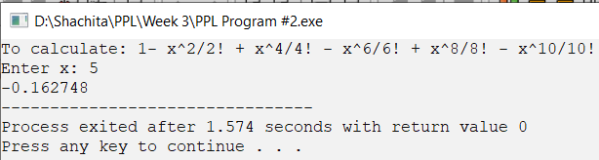

|  |  |  |  |
| --- | --- | --- | --- |
| **Name of Student: Shachita Jain** | | | **Class: CS-D** |
| **Enrollment No: 0827CS161203** | **Week Number: 03** | | **Batch: B1** |
| **Date of Experiment:** | **Date of Submission:** | | **Submitted on:** |
| **Remarks by faculty:** | | | **Grade:** |
| **Signature of student:** | | **Signature of Faculty:** | |

**Name of Program-3:** Write a C program to find the roots of a quadratic equation.

**Source Code:**

#include <iostream>

using namespace std;

int checkroots(int desc){

if(desc==0) return 1;

else if(desc>0) return 2;

else return 3;

}

int main(){

    float a,b,c;

    cout << "A quadratic equation is in the form of: ax^2+bx+c=0\n";

    cout << "Enter values for a, b and c: ";

    cin >> a >> b >> c;

    cout << endl;

    int desc = (b*b) - (4*a*c);

    switch(checkroots(desc)){

     case 1 :

     cout << "Real and Equal Roots:\n";

     cout << "x = " << -b/(2*a);

     break;

     case 2:

     cout << "Real and Different Roots\n";

     cout << "x1 = " << (-b + std::sqrt(desc))/(2*a) << "\tx2 = " << (-b - std::sqrt(desc))/(2*a);

     break;

     case 3:

     cout << "Imaginary Roots:\n";

     cout << "x1 = " << -b/ (2*a) << "+" << std::sqrt(-desc)/(2*a)<< "i\t";

     cout << "x2 = " << -b/ (2*a) << "-" << std::sqrt(-desc)/(2*a)<< "i";

    }

}

**Output Screen:**

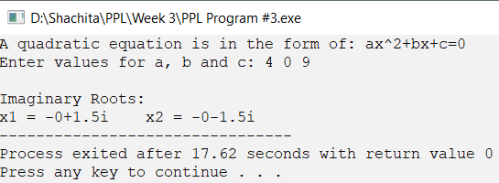

|  |  |  |  |
| --- | --- | --- | --- |
| **Name of Student: Shachita Jain** | | | **Class: CS-D** |
| **Enrollment No: 0827CS161203** | **Week Number: 03** | | **Batch: B1** |
| **Date of Experiment:** | **Date of Submission:** | | **Submitted on:** |
| **Remarks by faculty:** | | | **Grade:** |
| **Signature of student:** | | **Signature of Faculty:** | |

**Name of Program-4:** Write a C program to check whether a given 3 digit number is Armstrong number or not.

**Source Code:**

#include <iostream>

using namespace std;

int main(){

int x,digits=0,sum=0;

cin >> x;

int temp =x;

while(x){

x /= 10;

digits++;

}

x=temp;

while(temp){

int rem= temp%10;

sum += std::pow(rem, digits);

temp/=10;

}

if(sum==x) cout << "Armstrong Number!";

else cout << "Not an Armstrong Number :(";

}

**Output Screen:**

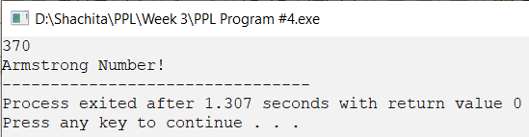

|  |  |  |  |
| --- | --- | --- | --- |
| **Name of Student: Shachita Jain** | | | **Class: CS-D** |
| **Enrollment No: 0827CS161203** | **Week Number: 03** | | **Batch: B1** |
| **Date of Experiment:** | **Date of Submission:** | | **Submitted on:** |
| **Remarks by faculty:** | | | **Grade:** |
| **Signature of student:** | | **Signature of Faculty:** | |

**Name of Program-5:** Write a C program to print the numbers in triangular form

1

1 2

1 2 3

1 2 3 4

**Source Code:**

#include <iostream>

using namespace std;

int main(){

int x;

cout << "Enter the number of lines to print: ";

cin >> x;

int r=0;

while(++r<=x){

    for(int i=1;i<=r;++i){

        cout << i << " ";

        }

        cout << std::endl;

    }

}

**Output Screen:**

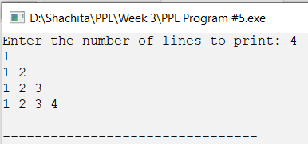

|  |  |  |  |
| --- | --- | --- | --- |
| **Name of Student: Shachita Jain** | | | **Class: CS-D** |
| **Enrollment No: 0827CS161203** | **Week Number: 04** | | **Batch: B1** |
| **Date of Experiment:** | **Date of Submission:** | | **Submitted on:** |
| **Remarks by faculty:** | | | **Grade:** |
| **Signature of student:** | | **Signature of Faculty:** | |

**Name of Program-1:** Write a C program to find the second largest integer in a list of integers.

**Source Code:**

#include <iostream>

using namespace std;

int main(){

int n, max, smax;

cout << "Enter the count of numbers: ";

cin >> n;

int a[n];

cout << "Enter the integers: \n";

for(int i=0; i<n;++i){

cin >> a[i];

if(i==0) max = a[i];

if(a[i] > max) smax = max,max = a[i] ;

else if(i==1) smax = a[i];

else if(a[i] > smax) smax = a[i];

}

cout << "Second Maximum number is: " << smax;

}

**Output Screen:**

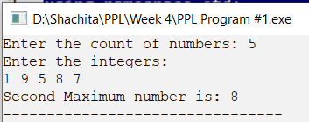

|  |  |  |  |
| --- | --- | --- | --- |
| **Name of Student: Shachita Jain** | | | **Class: CS-D** |
| **Enrollment No: 0827CS161203** | **Week Number: 04** | | **Batch: B1** |
| **Date of Experiment:** | **Date of Submission:** | | **Submitted on:** |
| **Remarks by faculty:** | | | **Grade:** |
| **Signature of student:** | | **Signature of Faculty:** | |

**Name of Program-2:** Write a C program to perform the following:

1. Addition of two matrices
2. Multiplication of two matrices

**Source Code:**

#include <iostream>

#include <vector>

using namespace std;

#define vect(a,b) (a, vector<int>(b, 0))

bool checkAddition(int a, int b, int c, int d){

    if(a!=c) return false;

    if(b!=d) return false;

return true;

}

bool checkMultiplication(int a, int b, int c, int d){

    if(b!=c) return false;

return true;

}

void TakeMatrix(vector<vector<int> > &mat){

    for(int i=0; i< mat.size();++i){

        cout << "Enter elements from row " << i+1 << ", space seperately:";

        for(int j=0; j<mat[i].size() ; ++j) cin >> mat[i][j];}}

void printMatrix(vector<vector<int> > &mat){

    for(int i=0; i<mat.size();++i){

        cout << "\t| ";

        for(int j = 0; j<mat[i].size(); ++j) cout << mat[i][j] << " ";

        cout << "|\n";}}

void Addition(int a, int b){

    vector<vector<int> > matA vect(a,b), matB vect(a,b), matC vect(a,b);

    cout << "Enter Matrix A: \n"; TakeMatrix(matA);

    cout << "Enter Matrix B: \n"; TakeMatrix(matB);

    for(int i=0; i<a; ++i) for(int j=0; j<b;++j) matC[i][j] = matA[i][j] + matB[i][j];

    cout << "\nMatrix A + Matrix B :\n" ; printMatrix(matC);}

void Multiplication(int a, int b, int d){

    vector<vector<int> > matA vect(a,b), matB vect(b,d), matC vect(a,d);

    cout << "Enter Matrix A: \n"; TakeMatrix(matA);

    cout << "Enter Matrix B: \n"; TakeMatrix(matB);

    for(int i=0; i<a; ++i) for(int j=0; j<d;++j) for(int k=0; k<b;++k) matC[i][j] += matA[i][k] * matB[k][j];

    cout << "\nMatrix A x Matrix B :\n" ; printMatrix(matC);

}

int main(){

int a, b , c , d;

cout << "Enter Order of the Matrix A (m x n): ";

    cin >> a >> b;

    cout << "Enter Order of the Matrix B (m x n): ";

    cin >> c >> d;

    char op;

    cout << "Enter + for Addition\nEnter * for Multiplication\n";

    cin >> op;

    switch(op){

        case '+':

            if(!checkAddition(a,b,c,d)) {

                cout << "Addition not possible!";

                return -1;

            }

            Addition(a,b);

            break;

        case '*':

            if(!checkMultiplication(a,b,c,d)){

                cout << "Multiplication not possible!";

                return -1;

            }

            Multiplication(a,b,d);

            break;

    }

}

**Output Screen:**

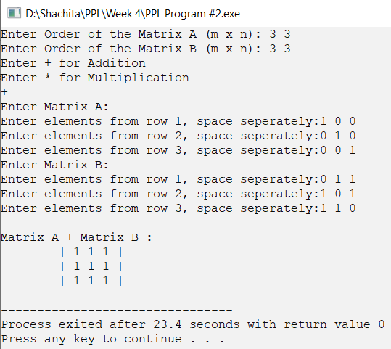

|  |  |  |  |
| --- | --- | --- | --- |
| **Name of Student: Shachita Jain** | | | **Class: CS-D** |
| **Enrollment No: 0827CS161203** | **Week Number: 04** | | **Batch: B1** |
| **Date of Experiment:** | **Date of Submission:** | | **Submitted on:** |
| **Remarks by faculty:** | | | **Grade:** |
| **Signature of student:** | | **Signature of Faculty:** | |

**Name of Program-3:** Write a C program to count and display positive, negative, odd and even numbers in an array.

**Source Code:**

#include <iostream>

using namespace std;

#define loop(a,b) for(int i=0;i<b;++i)cout<<a[i]<<" ";

#define val(ar,b) ar[b]=a[i];b++;

int main(){

    int n;

    cout << "Enter count of integers: ";

    cin >> n;

    int a[n],pos[n], neg[n], odd[n], even[n], pc=0, nc=0, oc=0, ec=0;

    cout<< "Enter the integers: \n";

    for(int i=0;i<n;++i){

        cin >> a[i];

        if(a[i] >= 0){

            val(pos,pc)

        }

        else {

            val(neg, nc)

        }

        if(a[i]%2) {

            val(odd,oc)

        }

        else {

            val(even,ec)}}

    cout << "Positive numbers are: \n";

    loop(pos, pc);

    cout << "\nNegative numbers are: \n";

    loop(neg, nc);

    cout << "\nEven numbers are: \n";

    loop(even,ec);

    cout << "\nOdd numbers are: \n";

    loop(odd, oc);

}

**Output Screen:**

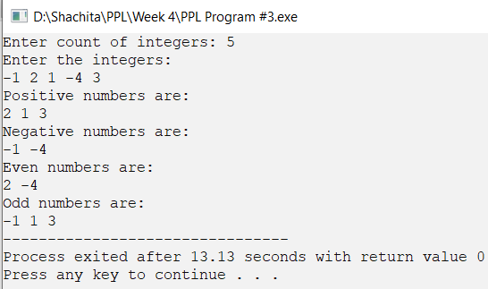

|  |  |  |  |
| --- | --- | --- | --- |
| **Name of Student: Shachita Jain** | | | **Class: CS-D** |
| **Enrollment No: 0827CS161203** | **Week Number: 04** | | **Batch: B1** |
| **Date of Experiment:** | **Date of Submission:** | | **Submitted on:** |
| **Remarks by faculty:** | | | **Grade:** |
| **Signature of student:** | | **Signature of Faculty:** | |

**Name of Program-4:** Write a C program to merge two sorted arrays into another array in a sorted order.

**Source Code:**

#include <iostream>

using namespace std;

#define in(ar, s) for(int i=0; i<s; ++i) cin >> ar[i]

int main(){

    int n1,n2;

    cout << "Enter size of Array 1: ";

    cin >> n1;

    cout << "Enter size of Array 2: ";

    cin >> n2;

    int a[n1], b[n2], c[n1+n2];

    cout << "Enter elements of Array 1 in sorted order: ";

    in(a,n1);

    cout << "Enter elements of Array 2 in sorted order: ";

    in(b,n2);

    int ai=0,bi=0,ci=0;

    while(ci<n1+n2){

        if(ai<n1 && bi <n2) {

            if(a[ai] <b[bi]){

                c[ci]= a[ai];

                ai++;}

            else {

                c[ci] = b[bi];

                bi++;}}

        else if(ai==n1){

            c[ci]=b[bi];

            bi++;}

        else {

            c[ci]= a[ai];

            ai++;

        }

        ci++;

    }

    cout << "Merged Array in sorted form is: \n";

    for(int i=0; i<ci; ++i) cout << c[i] << " ";

}

**Output Screen:**

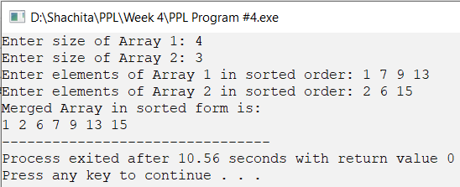

|  |  |  |  |
| --- | --- | --- | --- |
| **Name of Student: Shachita Jain** | | | **Class: CS-D** |
| **Enrollment No: 0827CS161203** | **Week Number: 04** | | **Batch: B1** |
| **Date of Experiment:** | **Date of Submission:** | | **Submitted on:** |
| **Remarks by faculty:** | | | **Grade:** |
| **Signature of student:** | | **Signature of Faculty:** | |

**Name of Program-5:** Write a C program to find the frequency of a particular number in a list of integers.

**Source Code:**

# #include <iostream>

using namespace std;

#define in(ar, s) for(int i=0; i<s; ++i) cin >> ar[i]

int main(){

    int n, num, freq=0;

    cout << "Enter size of Array: ";

    cin >> n;

    int a[n];

    cout << "Enter elements of array: ";

    in(a,n);

    cout << "Enter number to search: ";

    cin >> num;

    for(int i=0; i<n;++i){

        if(a[i]==num) freq++;

    }

    cout << "Number " << num << " appeared " << freq << " times!";

}

**Output Screen:**

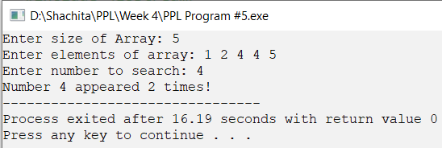

|  |  |  |  |
| --- | --- | --- | --- |
| **Name of Student: Shachita Jain** | | | **Class: CS-D** |
| **Enrollment No: 0827CS161203** | **Week Number: 05** | | **Batch: B1** |
| **Date of Experiment:** | **Date of Submission:** | | **Submitted on:** |
| **Remarks by faculty:** | | | **Grade:** |
| **Signature of student:** | | **Signature of Faculty:** | |

**Name of Program-1:** Write a C program that uses functions to perform the following operations:

1. To insert a sub string into a given main string from a given position.
2. To delete n characters from a given position in a given string.

**Source Code:**

#include <iostream>

using namespace std;

#define a(x,y) a.substr(x, y)

int main(){

    string a, b, c;

    cout << "Enter the string: ";

    cin >> a;

    char ch;

    cout << "+ to add n characters\n- to delete n characters\n";

    cin >> ch;

    int n;

    cout << "Give position: ";

    cin >> n;

    switch(ch){

        case '+':

            cout << "Enter the string: ";

            cin >> b;

            c = a(0,n-1) + b + a(n,a.size()-1);

            break;

        case '-':

            c = a(n, a.size()-1);

    }

     cout << c;}

**Output Screen:**

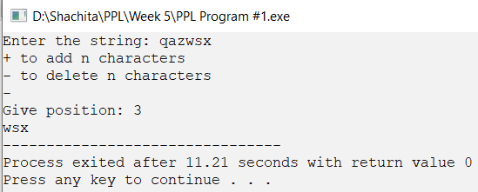

|  |  |  |  |
| --- | --- | --- | --- |
| **Name of Student: Shachita Jain** | | | **Class: CS-D** |
| **Enrollment No: 0827CS161203** | **Week Number: 05** | | **Batch: B1** |
| **Date of Experiment:** | **Date of Submission:** | | **Submitted on:** |
| **Remarks by faculty:** | | | **Grade:** |
| **Signature of student:** | | **Signature of Faculty:** | |

**Name of Program-2:** Write a C program to determine if the given string is a palindrome or not.

**Source Code:**

#include <iostream>

using namespace std;

int main(){

    string a;

    int i(0);

    cout << "Enter a string: ";

    cin >> a;

    int size = a.size();

    for(; i<size/2; ++i) if(a[i] != a[size-i-1]) break;

    if(i == size/2) cout << "is palindrome";

    else cout << "not palindrome";

}

**OUTPUT SCREEN**

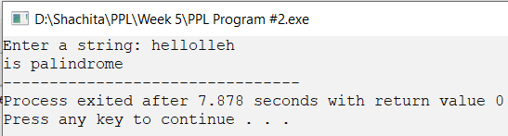

|  |  |  |  |
| --- | --- | --- | --- |
| **Name of Student: Shachita Jain** | | | **Class: CS-D** |
| **Enrollment No: 0827CS161203** | **Week Number: 05** | | **Batch: B1** |
| **Date of Experiment:** | **Date of Submission:** | | **Submitted on:** |
| **Remarks by faculty:** | | | **Grade:** |
| **Signature of student:** | | **Signature of Faculty:** | |

**Name of Program-3:** Write a C program to find a string within a sentence and replace it with another string.

**Source Code:**

#include <iostream>

using namespace std;

#define input(a) getline(cin,a)

int main(){

    string a,b,c, d;

    cout << "Enter a string: ";

    input(a);

    cout << "String to find: ";

    input(b);

    cout << "String to replace with:";

    input(c);

    int sidx = a.find(b);

    int eidx = sidx + b.size();

    d = a.substr(0, sidx) + c + a.substr(eidx, a.size()-1);

    cout << d;

}

**OUTPUT SCREEN**

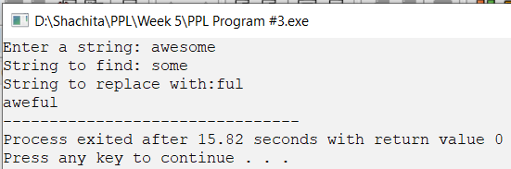

|  |  |  |  |
| --- | --- | --- | --- |
| **Name of Student: Shachita Jain** | | | **Class: CS-D** |
| **Enrollment No: 0827CS161203** | **Week Number: 05** | | **Batch: B1** |
| **Date of Experiment:** | **Date of Submission:** | | **Submitted on:** |
| **Remarks by faculty:** | | | **Grade:** |
| **Signature of student:** | | **Signature of Faculty:** | |

**Name of Program-5:** Write a C program to that reads a line of text and counts all occurrence of a particular word.

**Source Code:**

#include <iostream>

using namespace std;

int main() {

int res=0, N, M; string str, word;

cout << "Enter a string: ";

getline(cin, str);

cout << "Enter a word: ";

cin >> word;

N= str.length(); M= word.length();

for (int i = 0; i <= N - M; i++) {

int j;

for (j = 0; j < M; j++)

if (str[i+j] != word[j])

break;

if (j == M) {

res++;

j = 0;

}

}

cout << word << " occurs " << res << " times!";

}

**OUTPUT SCREEN**

